Ultimate TechnoGraphics Help MyPoster GmbH Print Up to 15,000 Orders per Day
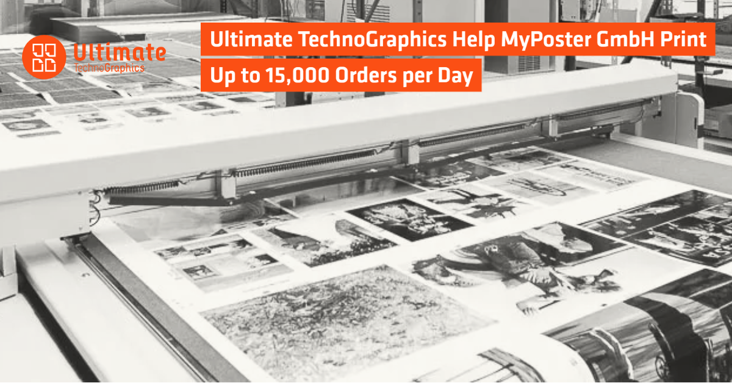
Montreal. Canada. December 9th, 2022. Ultimate TechnoGraphics, leader in imposition and finishing automation software, is proud to work with MyPoster GmbH, a fast-growing and well-known digital printer in Germany, to grow their photo print business with end-to-end workflow automation. Founded by René and Marc Ruhland in 2011, MyPoster GmbH has now grown to having more than 350 employees with a second production site officially opened in 2018. At that site, they recently hit the impressive 3 million printed product mark, only 4 years after official opening.
Today, MyPoster GmbH print up to 15,000 orders per day, including calendars, photo books, greeting cards, digital photo prints and much more. The variety of their product offering is managed efficiently in production and postpress with the help of multiple industry vendors, including Ultimate TechnoGraphics.
Investment in Technology Innovation
MyPoster GmbH manufacture every order themselves at their two locations in Bergkirchen in Bavaria and Bitterfeld in Saxony-Anhalt. This way, they can make sure at every production step that the material and quality are perfect on every piece, with millimeter precision, while offering 24-hour express shipping. They see the importance of staying on top of the latest technologies as Ingo Mannherz, Technical Product Manager, explains: “We always use the latest and best machines and sophisticated workflows to ensure the highest possible efficiency and reliability of the processes.”
In Bergkirchen, for example, they print on HP Indigo digital presses. For cutting the sheets and stacking the blanks, MyPoster GmbH uses the Horizon SmartStacker, which is specially designed for the HP Indigo machines. SCODIX machines are also available on the production floor for finishing orders with special colors such as varnishes.
Fully Automated Workflow
From job ordering to shipping, the workflows at MyPoster GmbH are automated “to the max” as per Mannherz. The central piece of their workflow is their ERP software developed by an internal programming team. It provides the entire logic, communicates with all systems and machines, receives feedback on order status and initiates further production steps.
Print products are ordered online directly on www.myposter.de through a web-to-print system. The ERP solution then transfers the order data to Enfocus Switch which prepares the print file. The sheets are imposed using Ultimate Impostrip®, which has the speed required for the high throughput at MyPoster GmbH. Ultimate Bindery® finally takes over the imposed job and provides it with all the necessary parameters that are required for the automatic setup of the machines in postpress.
Removing Human-Dependency
By automating finishing with Ultimate Bindery®, MyPoster GmbH eliminate all manual interventions from production to the point that “operators no longer have to manually intervene – they usually only move paper around on the production floor when required”, according to MyPoster GmbH Technical Product Manager. Removing this human-dependency was key for MyPoster GmbH. With end-to-end automation, production starts in the middle of the night, when everybody is still sleeping. Their ERP system collects all incoming jobs online, prepares them for production and transfers them to the subsequent systems at 3AM. The pipeline is already full when work begins, and production can begin straight away.
Ingo Mannherz summarizes: “The coordinated interaction of Enfocus Switch, Ultimate Impostrip®, Ultimate Bindery® and the Horizon SmartStacker creates the degree of automation that is absolutely necessary to be able to produce the highly individualized orders of our customers in a time- and cost-efficient manner”.
MyPoster GmBH automated print workflow was built by Impressed GmBH, print workflow integrators and Ultimate Reselling Partner.
To discover how MyPoster GmbH use Ultimate Bindery® to automate their Horizon SmartStacker, and read the full user story, visit: www.imposition.com/testimonial/finishing-automation-myposter
###

About Ultimate TechnoGraphics (www.imposition.com)

Automation drives results in printing. This is the foundation of all our software development and today, Print Service Providers worldwide benefit from increased productivity in a digital and hybrid environment. Ultimate TechnoGraphics invented digital imposition with the first release of Ultimate Impostrip® in 1989, and has continued to play a leading role in the market ever since while providing the most innovative and progressive imposition products.

Today, Ultimate is a leader in imposition and finishing automation software solutions. The company has a rich history of providing and integrating imposition technologies into hardware and software workflow solutions for print industry leaders.

